**[Upstream Conceptual Data Modelling (UCDM) Dashboard Technical Documentation](https://app.powerbi.com/groups/5d3e94ff-90ac-45e5-8361-b802aabc3381/reports/9376f908-a8ba-4310-8aba-afdd44c2bc76/ReportSectionccfde49ba0301ba78a09)**

|  |  |  |
| --- | --- | --- |
| Editor | Date | Comment |
| Vaheed Khan | 02/08/2023 | Documentation after updates |
|  |  |  |

**Repository –** Latest Documentation and Report is Stored in the UCDM GitHub repository

**Link -** [Upload files · pvaheed/UCDM (github.com)](https://github.com/pvaheed/UCDM/upload)

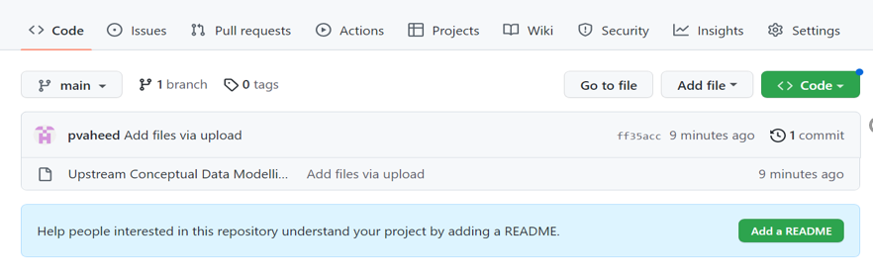

**Sections**

1. **Dashboard Overview**
   1. Home Page
   2. Data Entities
   3. Relationships
   4. OSDU Alignment
   5. Use Case
   6. QC-UDGP
   7. QC-CDO
   8. QC-UDAM
   9. QC-Collibra Template
2. **Data Sources**
   1. Snowflake
3. **Visuals**
   * 1. **Data Entities**
        1. Data Entity Count by Data Domain Steward
        2. Data Entity Count by L3 Data Domain
        3. Data Entities by UDGP/CDO Approval Status
     2. **Relationships**
        1. Incoming Relationships
        2. Outgoing Relationships
     3. **OSDU Alignment**
        1. OSDU Entity Result
     4. **Use case**
     5. **QC-UDGP**
        1. Data Domain Flag
        2. Data Domain Owner
        3. Data Domain Steward
        4. Data Entity Definition Source
        5. Business Capability
        6. Level 1 Data Domain
        7. Level 2 Data Domain
        8. Level 3 Data Domain
        9. Level 4 Data Domain
     6. **QC-CDO**
        1. Data Domain Flag
        2. 2 – Data Owner
        3. Lead Data Steward
        4. 18 – Community
        5. 19 – Subcommunity
        6. 7a - Data Classification
        7. zz9 - Business Data Domain (L1)
        8. zz6 - Business Data Domain (L2)
        9. 3 - Data Source
     7. **QC-UDAM**
        1. Data Model
        2. Use Case
        3. Data Function
        4. Data Entity Top Level
        5. Data Entity Version
        6. 3 – Data Source
     8. **QC-Collibra Template**

**Dashboard Overview:**

**Link -** [UCDM - Power BI](https://app.powerbi.com/groups/me/reports/2b9011a3-e682-4434-aa28-ee3e42a13113/ReportSection085696f15e4a60ccaed5)

The aim to build Upstream Conceptual Data Model Dashboard is to provide clarity to Business Management, Data domain stewards, Data custodian, Capability Architects etc. on various Data Domains, related Data Entities, and Business Capabilities.

All the visuals are being fed by four tables which are coming from only data source which is Snowflake.

All pages of this dashboard are attached below

Home Page:

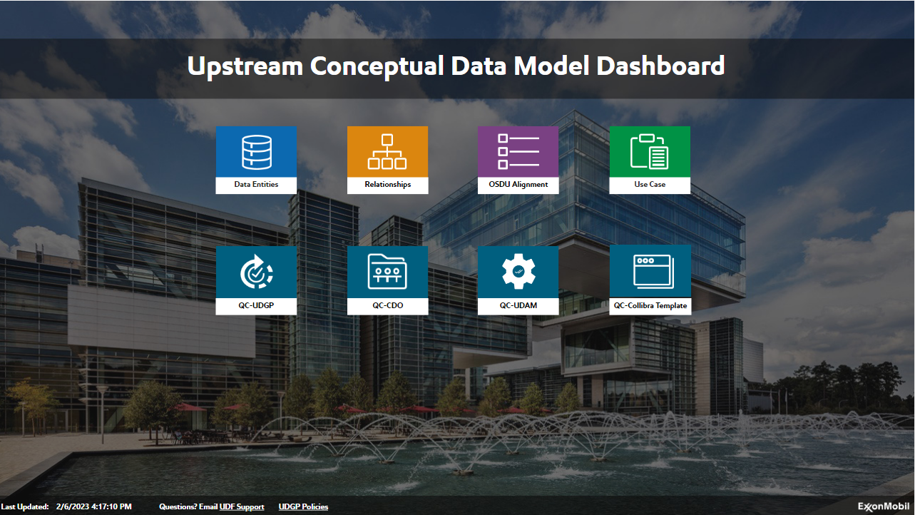

Data Entities page:

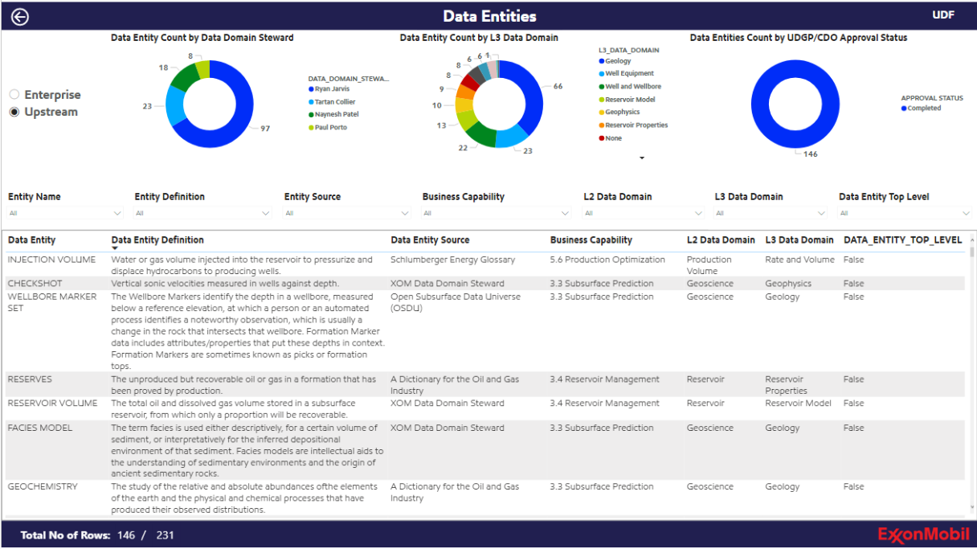

Relationships page:

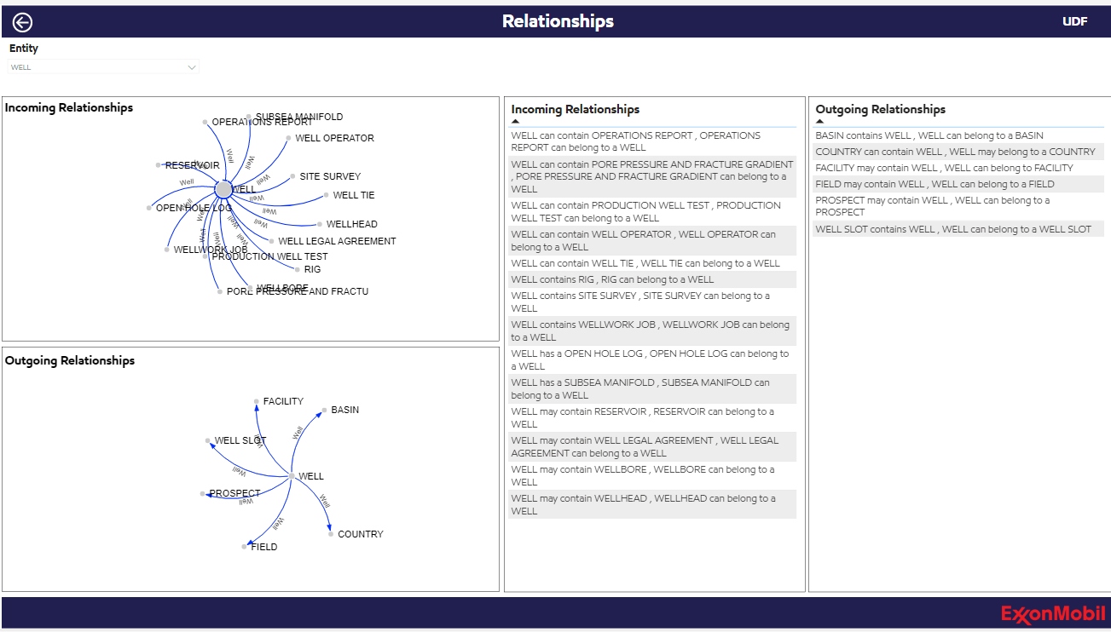

OSDU Alignment page:

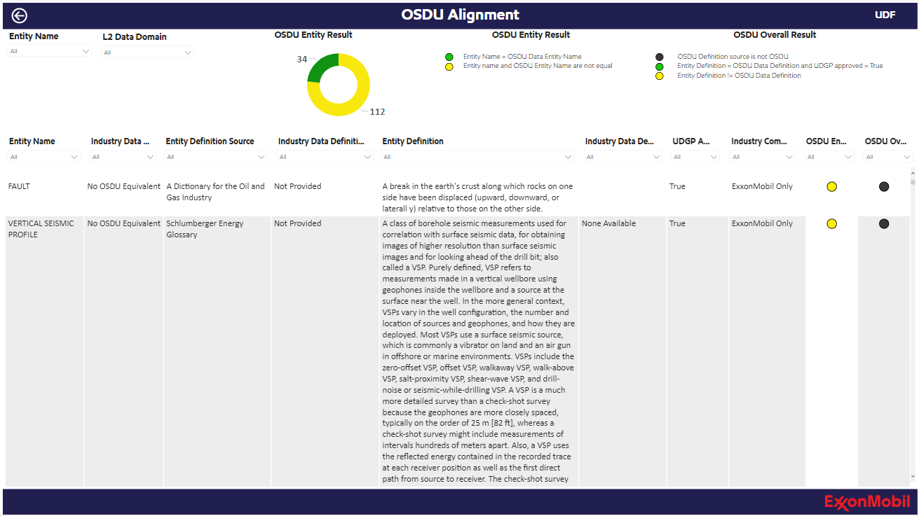

Use Case page:

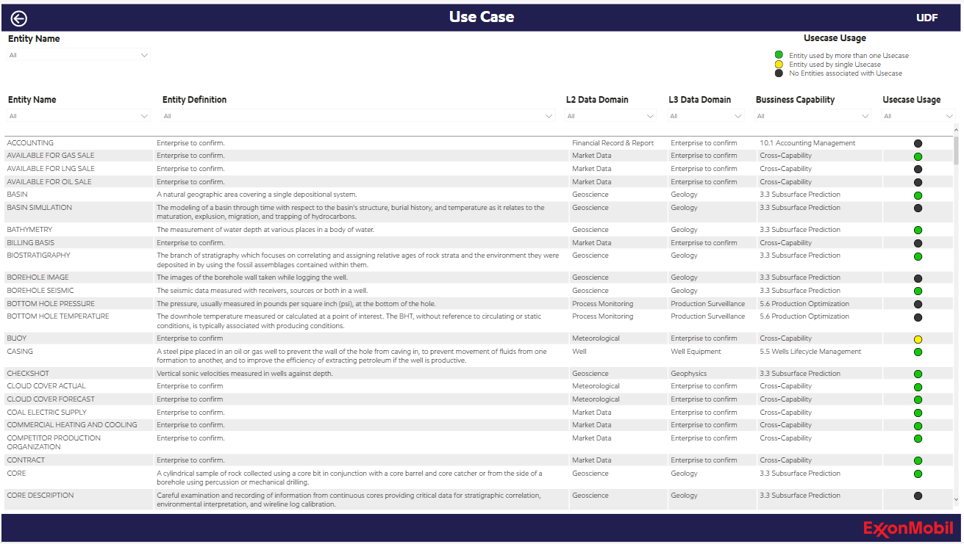

QC-UDGP page:

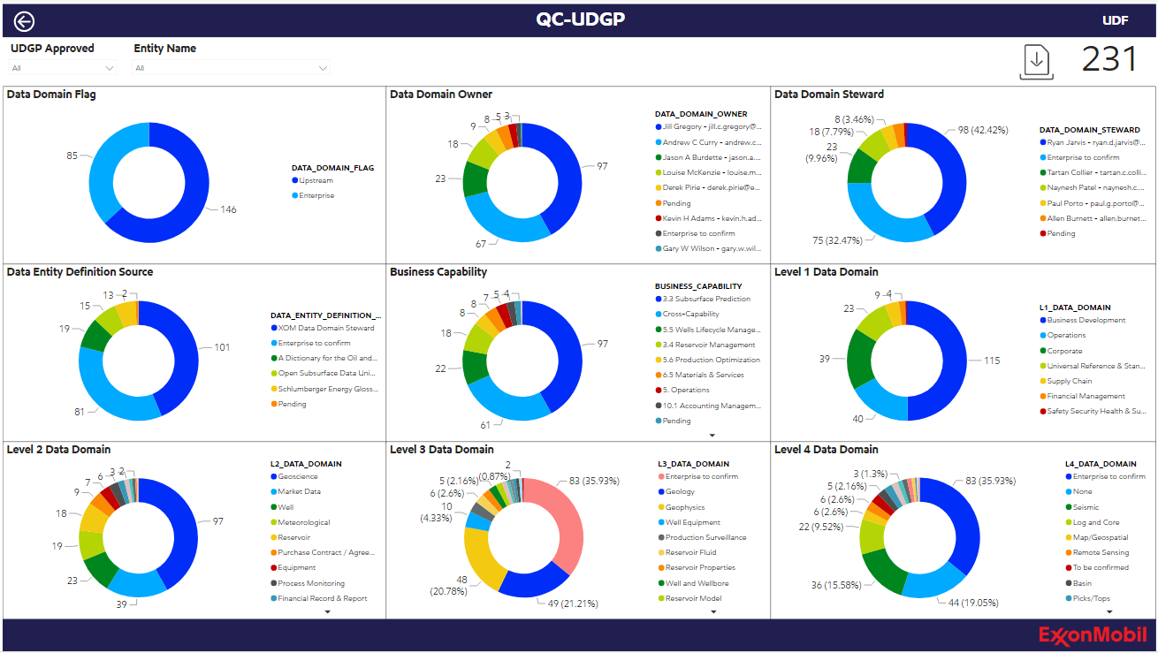

QC-CDO page:

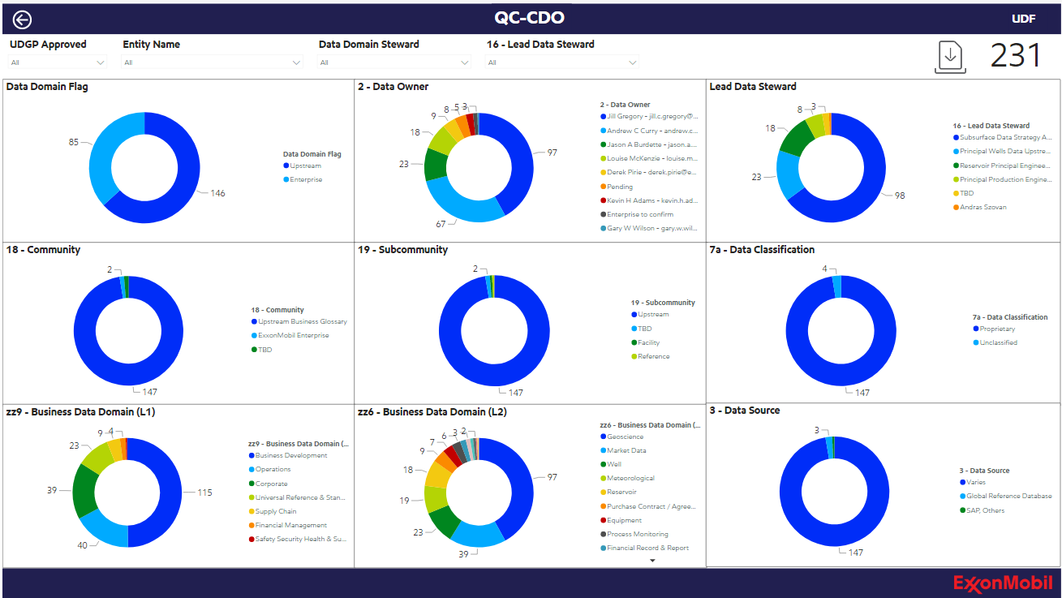

QC-UDAM page:

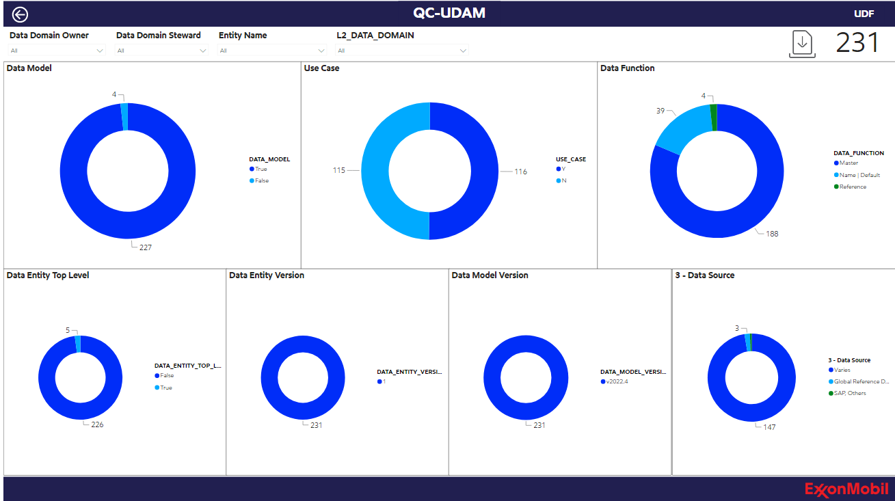

QC-Collibra Template page:

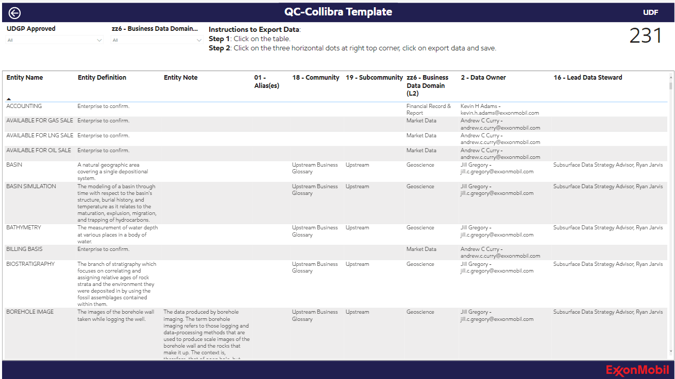

**Data Sources:**

Snowflake

This dashboard mainly use the data from Snowflake DATA_FOUNDATION_WH, ENRICHMENT_DB, DATA_FOUNDATION SCHEMA to fetch the data to the visuals. Below are the tables used in this dashboard.

* SYNC_MODEL_RELATIONSHIPS
* LOOKUP_USE_CASE
* SYNC_MODEL_ENTITIES
* SYNC_MODEL_SUBMODELS

**Visuals:**

**Home Page:**



Home page consists of headline **Upstream Conceptual Data Model Dashboard** and navigation icons to each page in the body along with Last Updated date, UDF Support email link, UDGP Policies navigation and Exxonmobil logo in the bottom.

**Data Entities page:**



The SYNC MODEL ENTITIES and LOOKUP USE CASE tables from the Snowflake DATA FOUNDATION WH warehouse ENRICHMENT DB database are the data sources for this page. These tables will help to get the results for Data Entity Count by Data Domain Steward, Data Entity Count by L3 Data Domain, and Data Entities by UDGP/CDO Approval Status in the visuals. Below, we can see the table that is straightforward coming from SYNC MODEL ENTITIES table having columns Entity Name, Entity Definition, Entity Source, Business Capability, L2 Data Domain, L3 Data Domain, Data Entity Top Level You can view everything based on your enterprise or upstream level. Status is shown by the below logic:

|  |  |  |
| --- | --- | --- |
| **UDGP APPROVED** | **CDO APPROVED** | **STATUS** |
| True | True | COMPLETED |
| True | False | SUBMITED TO CDO |
| False | True | IN PROGRESS |
| False | False | IN PROGRESS |

Slicers:

* The top left radio button slicers can refresh the entire page which are coming from SYNC_MODEL_ENTITIES (DATA_DOMAIN_FLAG) column.
* All the others slicers are multi-select and can refresh at table level.

Data Entity Count by Data Domain Steward:

* This visual presents count of data entity by data domain steward which is coming from SYNC_MODEL_ENTITIES table DATA_DOMAIN_STEWARD_1 and DATA_ENTITY columns.

Data Entity Count by L3 Data Domain:

* This visual gives count of data entity by L3 data domain which is coming from SYNC_MODEL_ENTITIES and LOOKUP_USE_CASE tables L3_DATA_DOMAIN and DATA_ENTITY columns respectively.

Data Entities by UDGP/CDO Approval Status:

* This visual represents data entities by UDGP/CDO approval status which is coming from SYNC_MODEL_ENTITIES table STATUS_DERIVED and DATA_ENTITY columns.

Table:

* All the data in the table is straight coming from SYNC_MODEL_ENTITIES table and all the columns are multi-select slicers which can refresh at table level.

**Relationships page:**



This visual data is sourced from snowflake DATA_FOUNDATION_WH warehouse ENRICHMENT_DB database tables where we are able to view data of incoming and outgoing relationships based on the selected Entity. Incoming Relationships visual is the visual representation of the Incoming Relationships table data and same goes for Outgoing Relationships as well.

Slicer:

* Slicer Entity is coming from SYNC_MODEL_SUBMODELS table which refreshes entire page according to the selected entity.

Incoming Relationships (table):

* Incoming Relationships data is coming from SYNC_MODEL_RELATIONSHIPS table which is bi-directionally related with SYNC_MODEL_SUBMODELS on SYNC_MODEL_RELATIONSHIPS (PARENT_DATA_ENTITY) and SYNC_MODEL_SUBMODELS (ENTITY) columns.

Outgoing Relationships (table):

* Outgoing Relationship data is coming from SYNC_ENTITIES_RELATIONSHIP_PAGE table which is related to SYNC_MODEL_SUBMODELS on SYNC_ENTITIES_RELATIONSHIP_PAGE (CHILD_DATA_ENTITY) and SYNC_MODEL_SUBMODELS (ENTITY) columns.

Note:

SYNC_ENTITIES_RELATIONSHIP_PAGE table is created to separate the incoming and outgoing relationships data and four columns has been used in SYNC_ENTITIES_RELATIONSHIP_PAGE table to use in the visual

Incoming Relationships (visual):

* It is the visual representation of Incoming relationships table data. The arrows are pointing inwards for the incoming relationships and has the information of SYNC_MODEL_ENTITIES (L2_DATA_DOMAIN) and SYNC_MODEL_RELATIONSHIPS (RELATIONSHIP_VERB) as tool tip.

Outgoing Relationships (visual):

* It is the visual representation of Outgoing relationships table data. The arrows are pointing outwards for the outgoing relationships and has the information of SYNC_MODEL_ENTITIES (L2_DATA_DOMAIN) and SYNC_ENTITIES_RELATIONSHIP_PAGE (RELATIONSHIP_VERB_INVERSE) as tool tip.

**OSDU Alignment page:**



The data is sourcing from SYNC_MODEL_ENTITIES table for all the slicers, visuals and table. From this page we are able to get the information of OSDU Entity Result which is having count of Entity Name = OSDU Data Entity Name and Entity Name & OSDU Entity Name are not equal, OSDU Overall Result which is having count of OSDU Definition Source is not OSDU, Entity Definition = OSDU Definition and UDGP approved = True and Entity Definition = OSDU Data Definition.

In the below table we can see the data for Entity Name, Industry Data Entity Name, Entity Definition Source, Industry Data Definition Source, Entity Definition, Industry Data Definition, UDGP Approved, Industry Comments, OSDU Entity Result, OSDU Overall Result all the data is being used in getting the OSDU Entity Result visual, OSDU Entity Result and OSDU Overall Result (all are multi-select slicers).

Slicers:

* All slicers are multi-select and coming from SYNC_MODEL_ENTITIES table. The top 2 slicers Entity Name and L2 Data Domain can refresh entire page and the column names slicers can refresh the table level data.

OSDU Entity Result:

* The data for this visual is coming from SYNC_MODEL_ENTITIES (OSDU Entity Result Column) which is a visual representation of counts of Entity Name = OSDU Data Entity Name and Entity Name & OSDU Entity Name are not equal.

OSDU Entity Result:

* Shows the distinct values of SYNC_MODEL_ENTITIES (OSDU Entity Result Column)

OSDU Overall Result:

* Shows the distinct values of SYNC_MODEL_ENTITIES (OSDU Overall Result)

Table:

* All the table data is coming from SYNC_MODEL_ENTITIES table and all the columns are multi-select slicers which can refresh table level data.

**Use Case page:**



This page shows the data of Usecase Usage by Entity. The data is coming from SYNC_MODEL_ENTITIES table and for one slicer Usecase Usage which is a measure coming from LOOKUP_USE_CASE table.

On the top right of the page the colors are defined to the 3 conditions Entity used by more than one Usecase, Entity used by single Usecase, No Entities associated with Usecases for Usecase Usage by Entity.

Slicers:

* All slicers are multi-select and are coming from SYNC_MODEL_ENTITIES table except Usecase Usage slicer which is also a multi-select but a measure written in LOOKUP_USE_CASE table.
* The top slicer ‘Entity Name’ can refresh all the page and remaining slicers are table level refresh.

Table:

* The data in the table refers to Entity Name, Entity Definition, L2 Data Domain, L3 Data Domain, Business Capability, Usecase Usage which can refresh according to the respective slicers.

**QC-UDGP page:**



This page is sourced from SYNC_MODEL_ENTITIES table and gives the information about count of following columns based on selected entities and UDGP approved.

1. Data Domain Flag
2. Data Domain Owner
3. Data Domain Steward
4. Data Entity Definition Source
5. Business Capability
6. Level 1 Data Domain
7. Level 2 Data Domain
8. Level 3 Data Domain
9. Level 4 Data Domain

Visuals:

* Each visual will be sliced in accordance with the Entities chosen and UDGP-approved, and it will display the count of data domain-related details connected to the specified Entities.

Slicers:

* The 2 slicers UDGP Approved and Entity Name are multi-select and can refresh entire page.

Export:

* Export symbol is used to navigate to a table which shows data regarding the selected entities in slicers in QC-UDGP page.
* Steps to export data is also present in the same page.

Image of export page

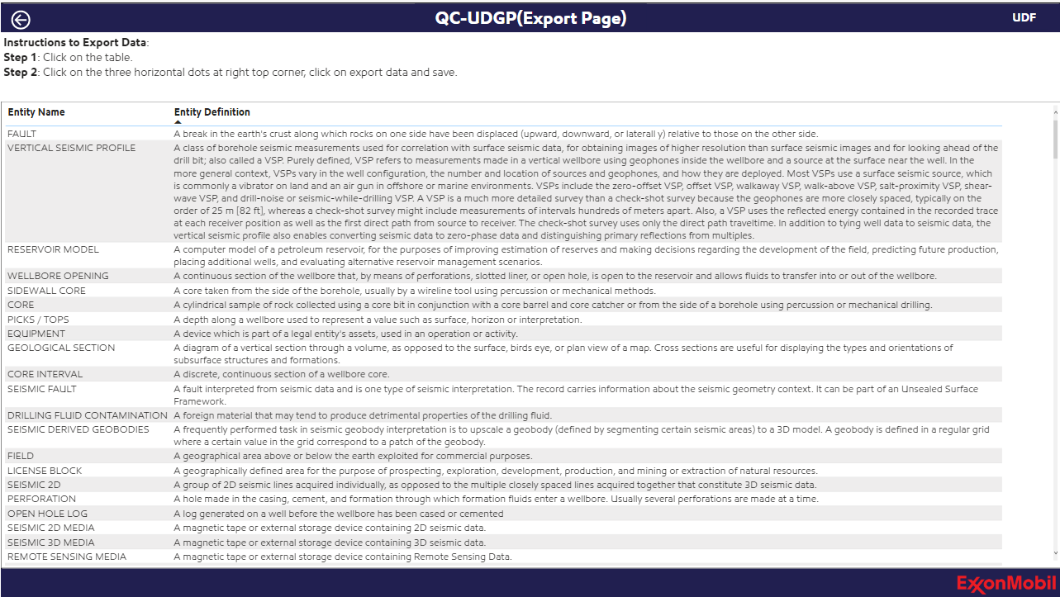

**QC-CDO page:**



This page is sourced from SYNC_MODEL_ENTITIES table and gives the information about count of following columns based on selected Entities, Data Domain Steward, 16 - Lead Data Steward and UDGP approved.

1. Data Domain Flag
2. 2 - Data Owner
3. Lead Data Steward
4. 18 – Community
5. 19 – Subcommunity
6. 7a - Data Classification
7. zz9 - Business Data Domain (L1)
8. zz6 - Business Data Domain (L2)
9. 3 - Data Source

Visuals:

* Each visual will be sliced in accordance with the Entities chosen, Data Domain Steward, 16 - Lead Data Steward and UDGP-approved, and it will display the count of above mentioned resources connected to the specified Entities.

Slicers:

* The 4 slicers UDGP Approved, Data Domain Steward, 16 - Lead Data Steward and Entity Name are multi-select and each can refresh entire page.

Export:

* Export symbol is used to navigate to a table which shows data regarding the selected entities in slicers in QC-CDO page.
* Steps to export data is also present in the same page.

Image of export page

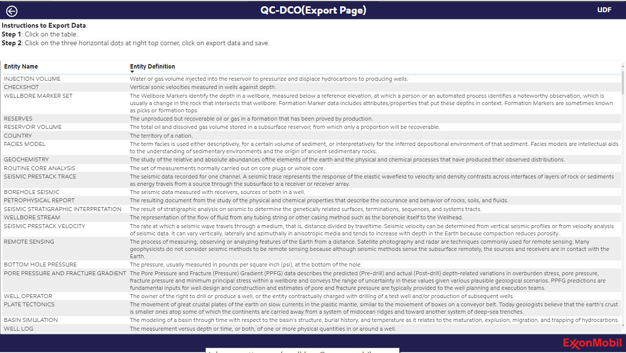

**QC-UDAM page:**



This page is sourced from SYNC_MODEL_ENTITIES and LOOKUP_USE_CASE tables and gives the information about count of following columns based on selected Entities, Data Domain Steward, Data Domain Owner and L2_DATA_DOMAIN.

1. Data Model
2. Use Case
3. Data Function
4. Data Entity Top Level
5. Data Entity Version
6. Data Model Version
7. 3 - Data Source

Visuals:

* Each visual will be sliced in accordance with the Entities chosen, Data Domain Steward, Data Domain Owner and L2_DATA_DOMAIN and it will display the count of above mentioned resources connected to the specified Entities.

Slicers:

* The 4 slicers Data Domain Steward, Data Domain Owner and L2_DATA_DOMAIN and Entity Name are multi-select and each can refresh entire page.

Export:

* Export symbol is used to navigate to a table which shows data regarding the selected entities in slicers in QC-UDAM page.
* Steps to export data is also present in the same page.

Image of export page

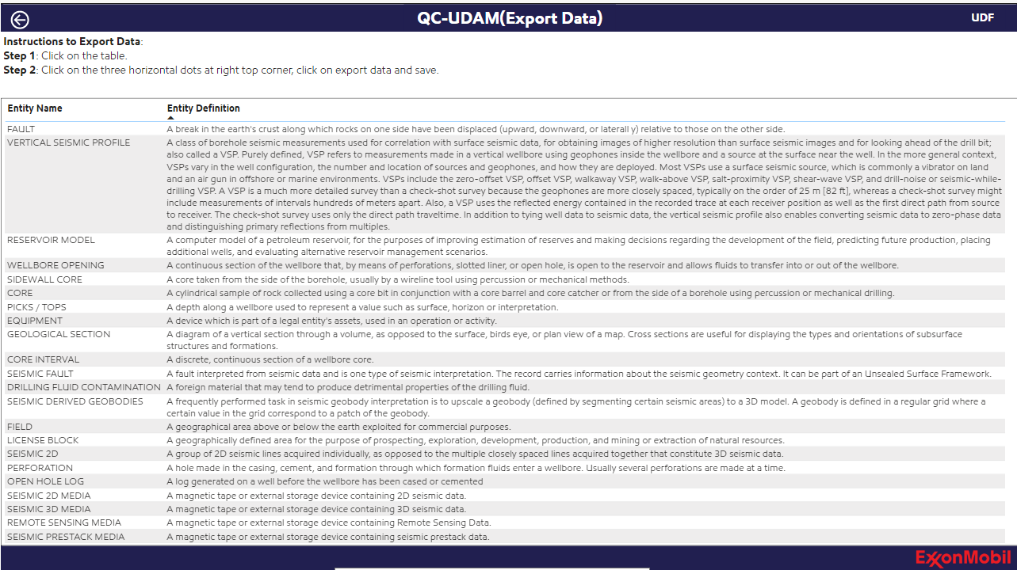

**QC-Collibra Template page:**



The data in this page is sourcing from snowflake SYNC_MODEL_ENTITIES table. This page doesn’t had any measures and calculations but with changes in some column names. The columns present in this page are DATA_ENTITY, DATA_ENTITY_DEFINITION, NOTES, ALIAS, CDO_COMMUNITY, CDO_SUBCOMMUNITY, L2_DATA_DOMAIN, DATA_DOMAIN_OWNER, CDO_LEAD_DATA_STEWARD and will be sliced according to UDGP_APPROVED and L2_DATA_DOMAIN.

Slicers:

* The 2 slicers UDGP_APPROVED and L2_DATA_DOMAIN are multi-select and can refresh the entire page.

Steps to export data is also present in the same page.